**Experiment Title 3**

**Student Name: Mohit Kumar UID: 20BCS9473**

**Branch: BE-CSE Section/Group: 20BCS-DM-714/A**

**Semester: 6 Subject Code: 20CSP-351**

**Subject Name: Competitive Coding-II Date of Performance: 16-03-2023**

1. **Aim:** To demonstrate the concept of Heap model problem 1
2. **Objective:** The objective is to solve problem of heap and its methods and priority queue.
3. **Code and output:**

**Problem 1: Last Stone Weight**

**Code:**

class Solution {

public int lastStoneWeight(int[] stones) {

Queue<Integer> queue = new PriorityQueue<>(Collections.reverseOrder());

for (int i : stones) queue.offer(i);

while (queue.size() > 1) {

int first = queue.poll();

int next = queue.poll();

if (first != next) {

queue.offer(first - next);

}

}

return queue.isEmpty() ? 0 : queue.poll();

}

}

**Output:**

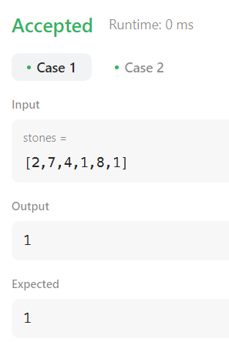

**Problem 2: Distant Barcodes**

**Code:**

class Solution {

class Bar {

int barcode;

int freq;

Bar(int barcode, int freq) {

this.barcode = barcode;

this.freq = freq;

}

}

public int[] rearrangeBarcodes(int[] barcodes) {

Map<Integer, Integer> map = new HashMap<>();

for (int n : barcodes) {

map.put(n, map.getOrDefault(n, 0) + 1);

}

PriorityQueue<Bar> pq = new PriorityQueue<>(

(a, b) -> b.freq - a.freq

);

for (int key : map.keySet()) {

pq.offer(new Bar(key, map.get(key)));

}

Bar prev = null;

for (int i = 0; i < barcodes.length; i++) {

Bar curr = pq.poll();

barcodes[i] = curr.barcode;

curr.freq--;

if (prev != null) {

pq.offer(prev);

}

if (curr.freq > 0) {

prev = curr;

}

else prev = null;

}

return barcodes;

}

}

**Output:**

